Work Divided
PathSense · natHACKS 2026 · How the team completes each phase

How We Work
We complete the project in four phases. All six of us finish Phase 1 before anyone starts Phase 2, then Phase 2 before Phase 3, and Phase 3 before Phase 4. A phase is complete only when its checkpoint passes.
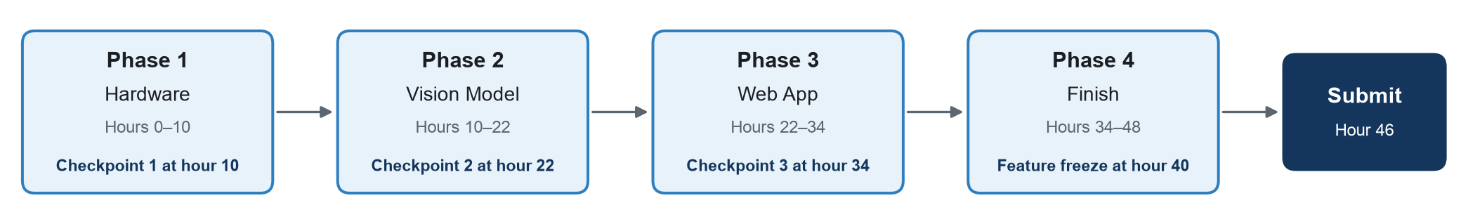

How to Read the Flowcharts
- Steps run from left to right. Tasks in the same step happen at the same time.
- An arrow means the task on the left must be finished before the task on the right can be finished.
- Each person has the same colour in every phase.
- If you are waiting for an earlier step, prepare your code or materials so you can finish quickly once it is ready.

Assignments
Team member | Phase 1: Hardware | Phase 2: Vision Model | Phase 3: Web App | Phase 4: Finish
Tatsat | Set up the Raspberry Pi | Stabilize results and test reliability | Add routing and connect the Pi to the server | Demo checks and offline backup
Ipsa | Select and mount the camera at the window | Calibrate the camera and mark the segments | Add black ice detection from weather data | Measure performance
Estella | Select the site and survey the sidewalk | Collect and label training data | Add saved routes and notifications | Presentation and Devpost
Kaleb | Set up the outdoor curb-cut sensor | Build the baseline detector | Build the city dashboard | Cold-weather readiness
Matthew | Record street footage for training | Train the model and run it on the Pi | Build the server on Render | Deployment stability and backup video
Kashish | Build the live preview and sensor tools | Build the data labeling tool | Build the live map and route planner | Accessibility review

Moving Between Phases
- At each checkpoint, the team meets for five minutes: what is done, what is blocked, and has the checkpoint passed?
- If the checkpoint has not passed, everyone helps finish it. Nobody starts the next phase early.
- Every task is a GitHub issue. Close it with a pull request when it is done.

Phase 1: Hardware (Hours 0–10)
Goal: set up the camera, the curb-cut sensor and the Raspberry Pi.
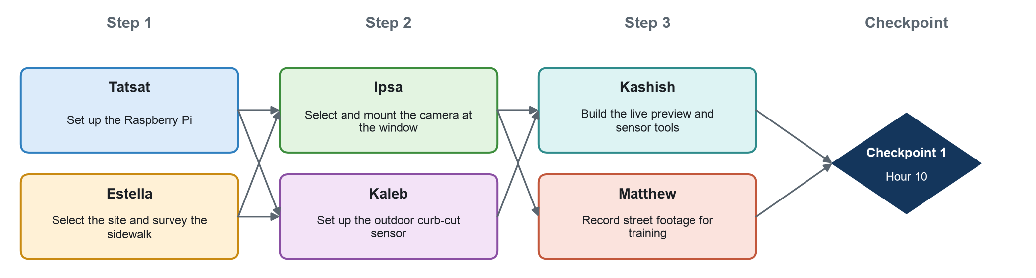
Step | Person | Task | Waits for | Hands off to
1 | Tatsat | Set up the Raspberry Pi | Nothing; start immediately | Ipsa, Kaleb, Kashish, Matthew
1 | Estella | Select the site and survey the sidewalk | Nothing; start immediately | Ipsa, Kaleb, Tatsat
2 | Ipsa | Select and mount the camera at the window | Tatsat (Pi ready), Estella (site chosen) | Kashish, Matthew
2 | Kaleb | Set up the outdoor curb-cut sensor | Tatsat (Pi ready), Estella (site chosen) | Kashish
3 | Kashish | Build the live preview and sensor tools | Ipsa (camera), Kaleb (sensor) | Checkpoint 1
3 | Matthew | Record street footage for training | Ipsa (camera) | Checkpoint 1; Estella in Phase 2
Checkpoint 1 (hour 10): The Raspberry Pi shows a clear view of the real sidewalk by day and night, records footage and reads the curb-cut sensor.
Prepare while you wait
- Ipsa: test the camera on the Pi at a desk.
- Kaleb: wire and test the sensor indoors with the Arduino.
- Kashish: write the preview and sensor tools using a test image.
- Matthew: write the recording script and test it with a laptop camera.

Phase 2: Vision Model (Hours 10–22)
Goal: detect the condition of each sidewalk segment from camera images.
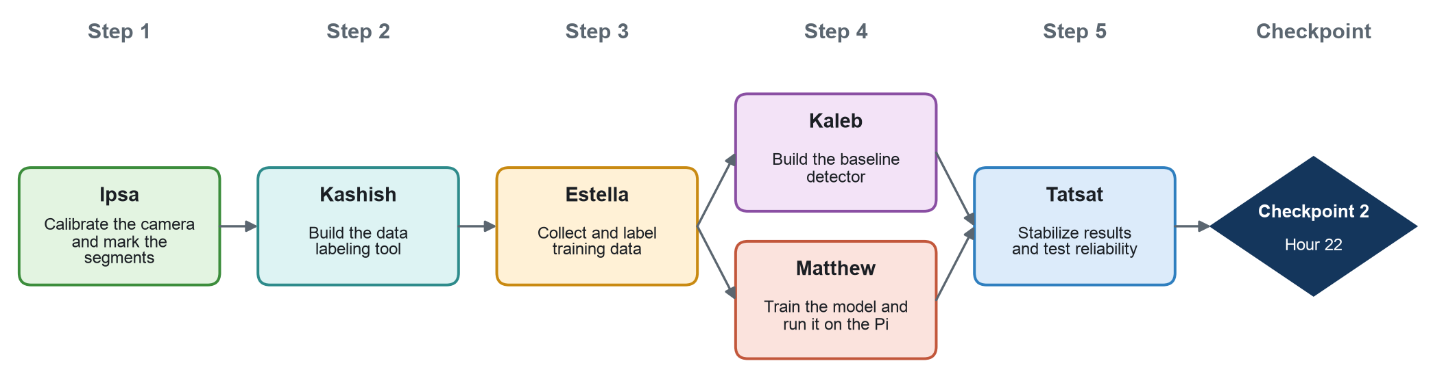
Step | Person | Task | Waits for | Hands off to
1 | Ipsa | Calibrate the camera and mark the segments | Checkpoint 1 | Kashish, Tatsat
2 | Kashish | Build the data labeling tool | Ipsa (segments marked) | Estella
3 | Estella | Collect and label training data | Kashish (labeling tool), Matthew (footage from Phase 1) | Kaleb, Matthew
4 | Kaleb | Build the baseline detector | Estella (labeled data) | Tatsat
4 | Matthew | Train the model and run it on the Pi | Estella (labeled data) | Tatsat
5 | Tatsat | Stabilize results and test reliability | Kaleb and Matthew (the more accurate detector) | Checkpoint 2
Checkpoint 2 (hour 22): At least 45 of 50 test cases are correct, updates appear within 2 seconds, and there are no false alerts over 10 minutes.
Prepare while you wait
- Kashish: build the labeling tool with placeholder segments.
- Estella: plan which conditions to capture, and when: day, dusk and night.
- Kaleb and Matthew: set up the detection and training code with a few sample images.
- Tatsat: write the smoothing logic and test it with recorded data.

Phase 3: Web App (Hours 22–34)
Goal: show live sidewalk conditions and accessible routes online.
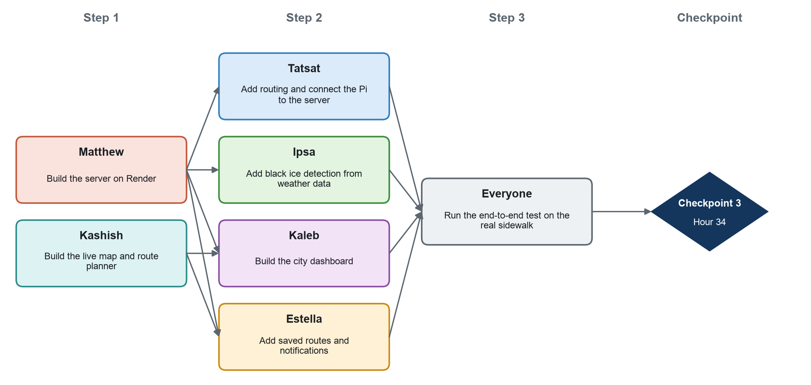
Step | Person | Task | Waits for | Hands off to
1 | Matthew | Build the server on Render | Checkpoint 2 | Tatsat, Ipsa, Kaleb, Estella
1 | Kashish | Build the live map and route planner | Checkpoint 2 | Kaleb, Estella
2 | Tatsat | Add routing and connect the Pi to the server | Matthew (server) | End-to-end test
2 | Ipsa | Add black ice detection from weather data | Matthew (server) | End-to-end test
2 | Kaleb | Build the city dashboard | Matthew (server), Kashish (web app) | End-to-end test
2 | Estella | Add saved routes and notifications | Matthew (server), Kashish (web app) | End-to-end test
3 | Everyone | Run the end-to-end test on the real sidewalk | All step 2 tasks | Checkpoint 3
Checkpoint 3 (hour 34): Blocking the real sidewalk updates the route on a phone, sends a notification and opens the route in Google Maps.
Prepare while you wait
- Tatsat: build the street map and routing with sample conditions.
- Ipsa: test the weather rules with saved weather data.
- Kaleb and Estella: design your pages with Kashish using sample data.

Phase 4: Finish (Hours 34–48)
Goal: stabilize the project, present it and submit on time.
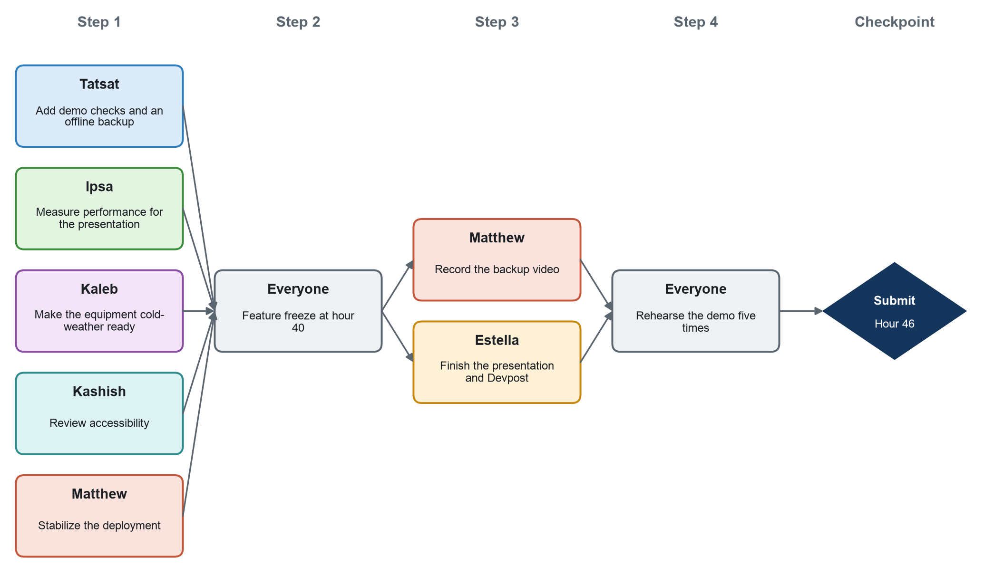
Step | Person | Task | Waits for | Hands off to
1 | Tatsat | Add demo checks and an offline backup | Checkpoint 3 | Feature freeze
1 | Ipsa | Measure performance for the presentation | Checkpoint 3 | Estella
1 | Kaleb | Make the equipment cold-weather ready | Checkpoint 3 | Feature freeze
1 | Kashish | Review accessibility | Checkpoint 3 | Estella
1 | Matthew | Stabilize the deployment | Checkpoint 3 | Feature freeze
2 | Everyone | Feature freeze at hour 40 | All step 1 tasks | Matthew, Estella
3 | Matthew | Record the backup video | Feature freeze | Rehearsals
3 | Estella | Finish the presentation and Devpost | Feature freeze, Ipsa (numbers), Kashish (screenshots) | Rehearsals
4 | Everyone | Rehearse the demo five times | Backup video, presentation | Submit by hour 46
Submit (hour 46): The demo is rehearsed five times and the Devpost submission is complete.
Prepare while you wait
- Estella: start the slides during Phase 3 and update them as results come in.

